Report: Web Development

Section-A: Directory Structure

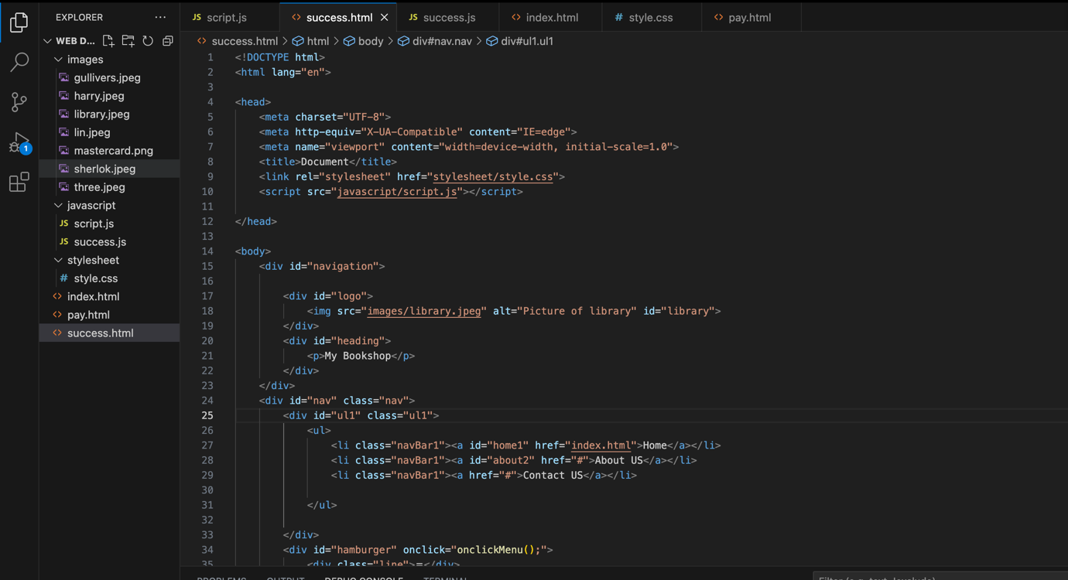

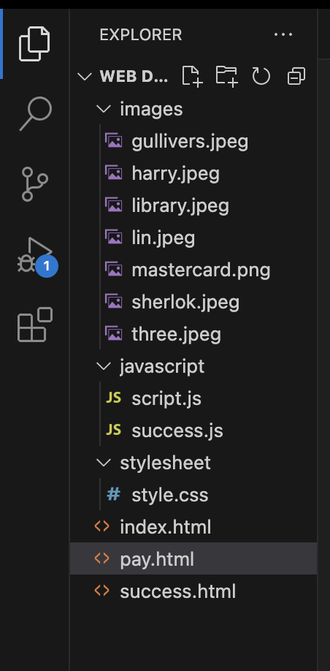

Root directory: This is the top-level directory which contains all of my website pages such as “index.html”, “pay.html” and “success.html” and also contains other directories and files for the website.

Also, I have made some assets folders such as images, stylesheet, and JavaScript, which contain all my images, CSS and JavaScript files, respectively.

To connect all these files and folders, the HTML pages often connect to other HTML pages, images, CSS stylesheets and JavaScript files via links. These links basically specify the path or the URL to the actual target file and allow the users to navigate between the pages and also use other required resources. For example, you can see the codes in lines 9 and 10 of how I linked my CSS stylesheet file and JavaScript file to the HTML page using href and rel respectively. And, in line 18 you can see how I linked my image using a proper file path.

All the pages are connected to different HTML pages, images and JavaScript files using the same linking process which can be seen above on the index page.

Section-B: Frontend

Desktop View: Home page

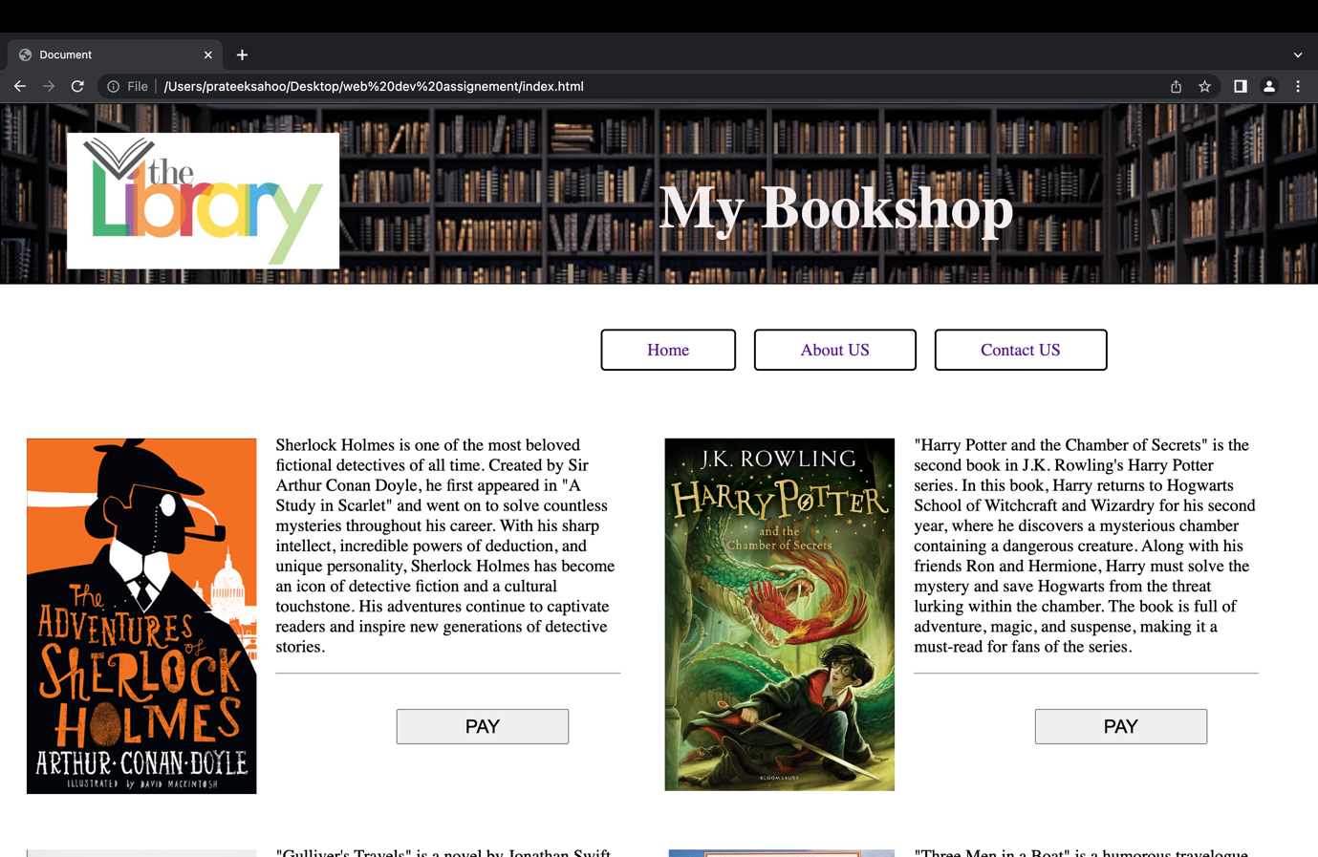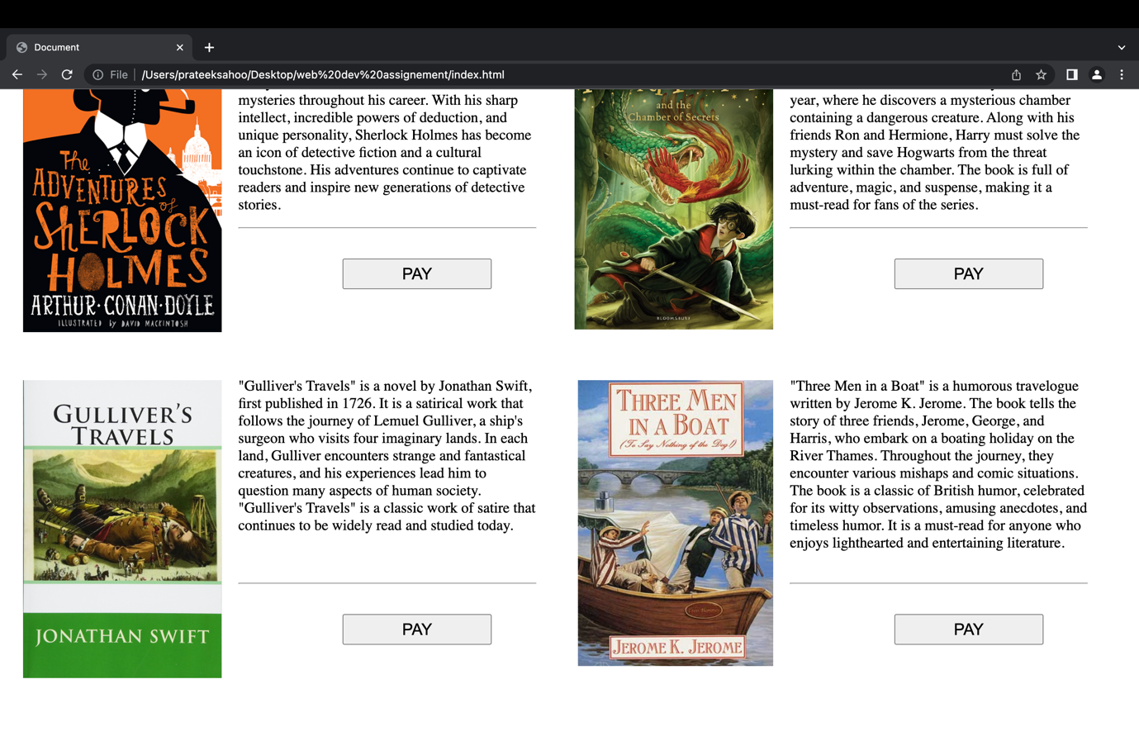

Desktop View: Pay Page

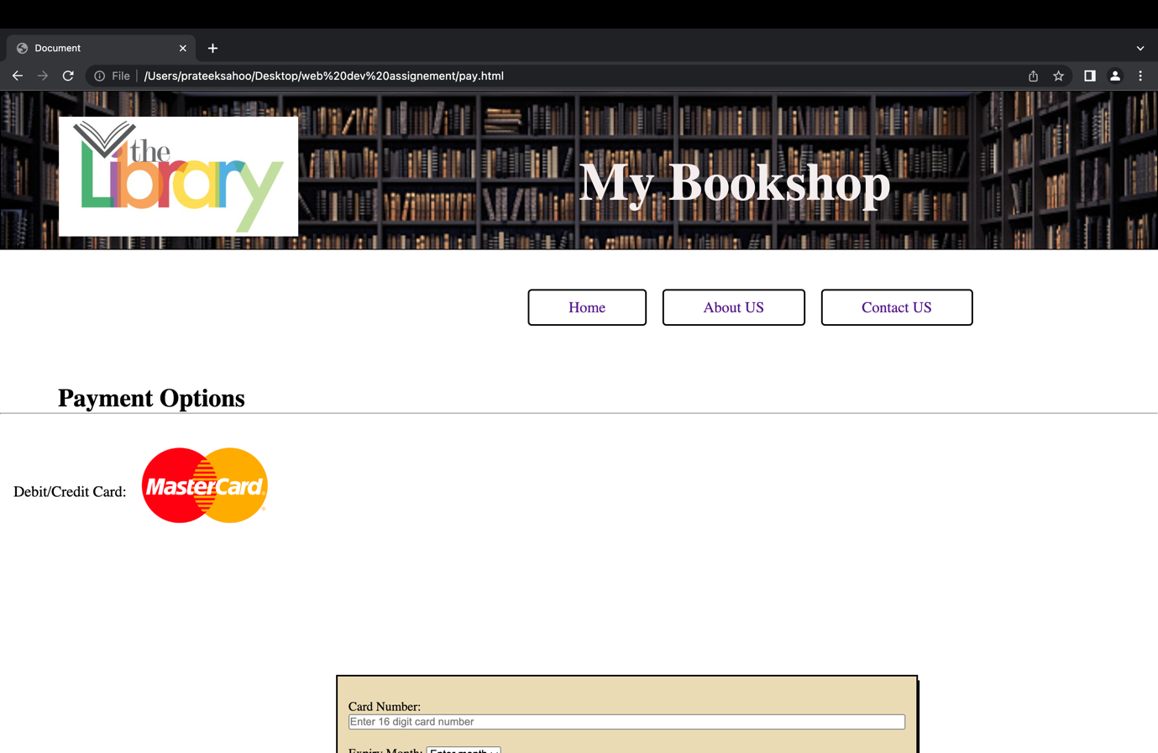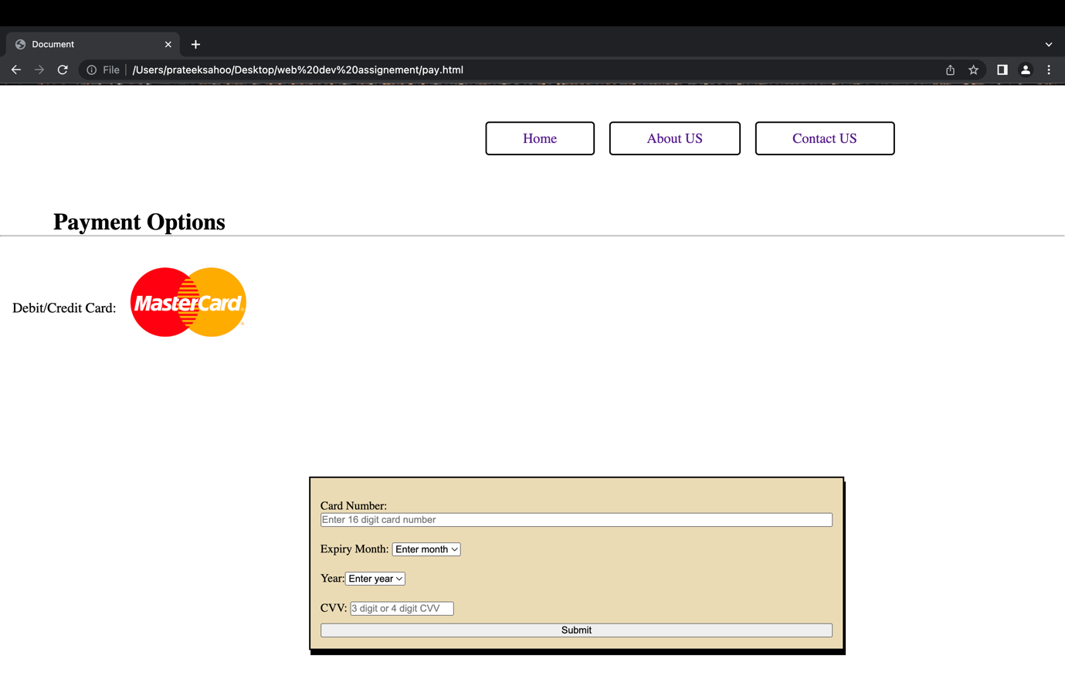

Desktop View: Success Page

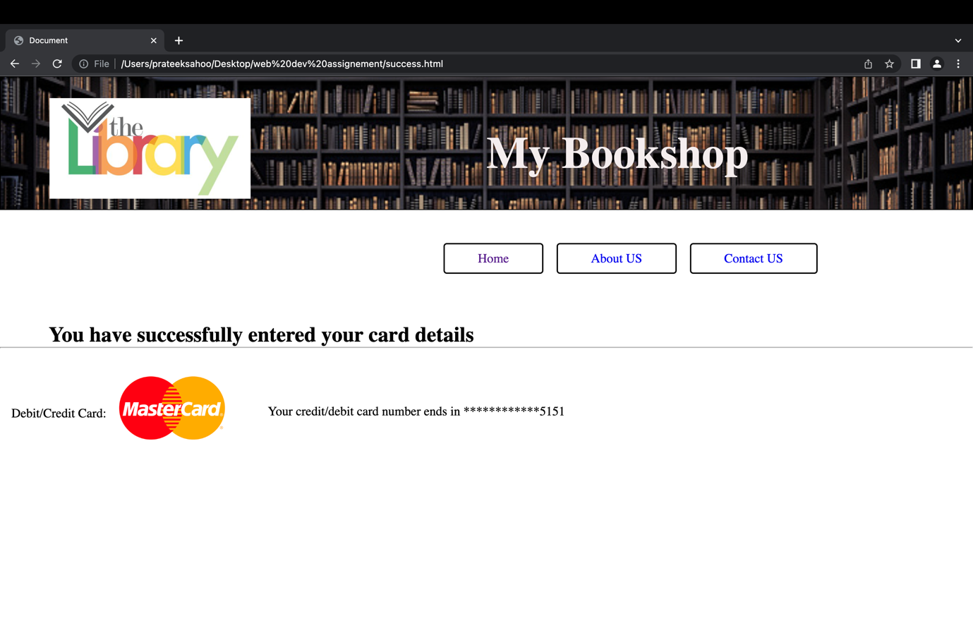

Smartphone view: Home page (iPhone XR view)

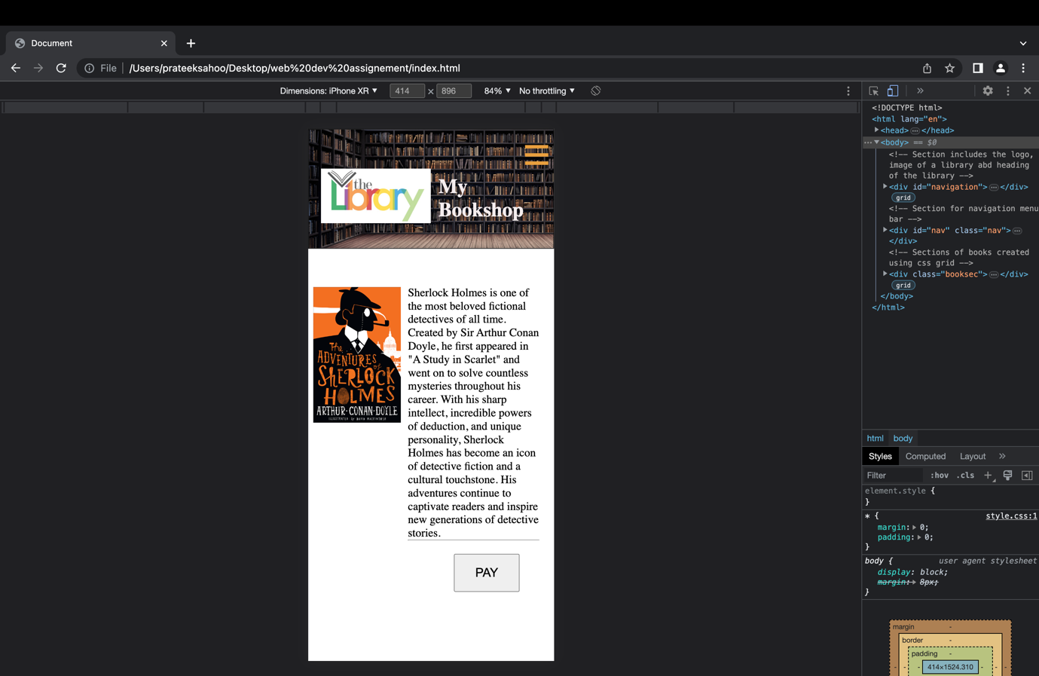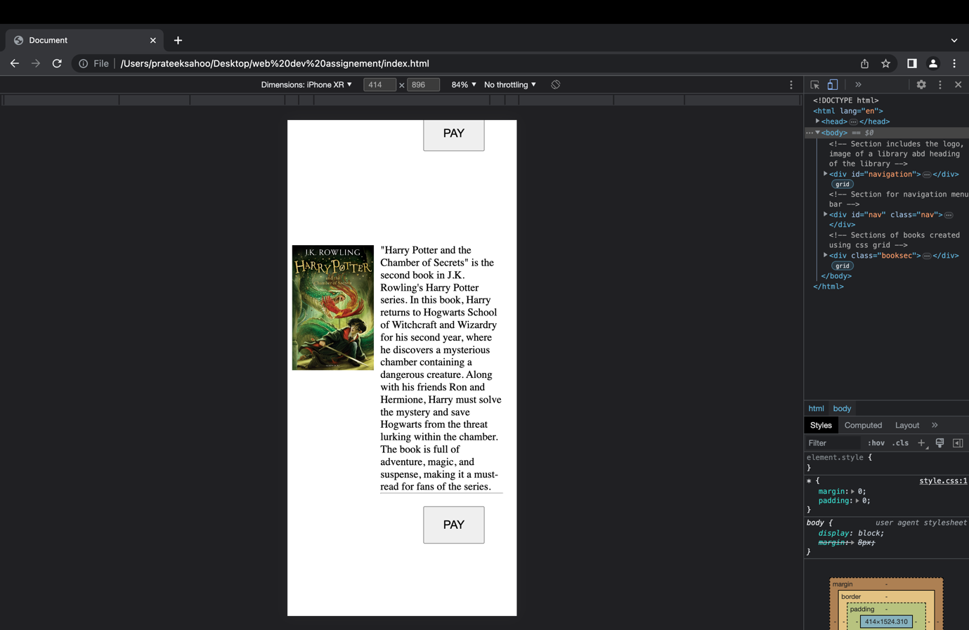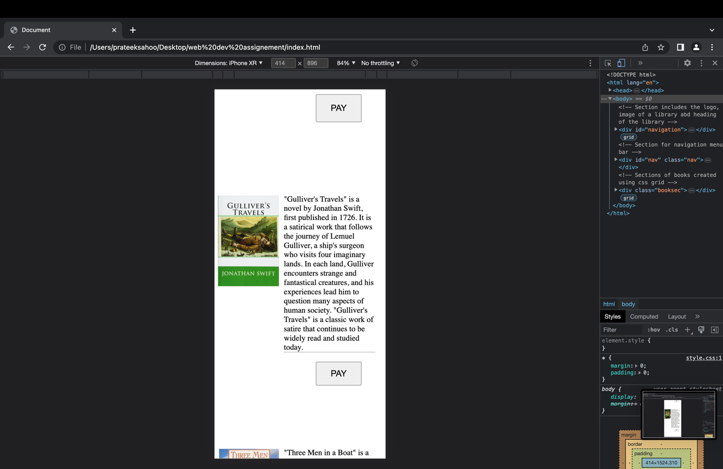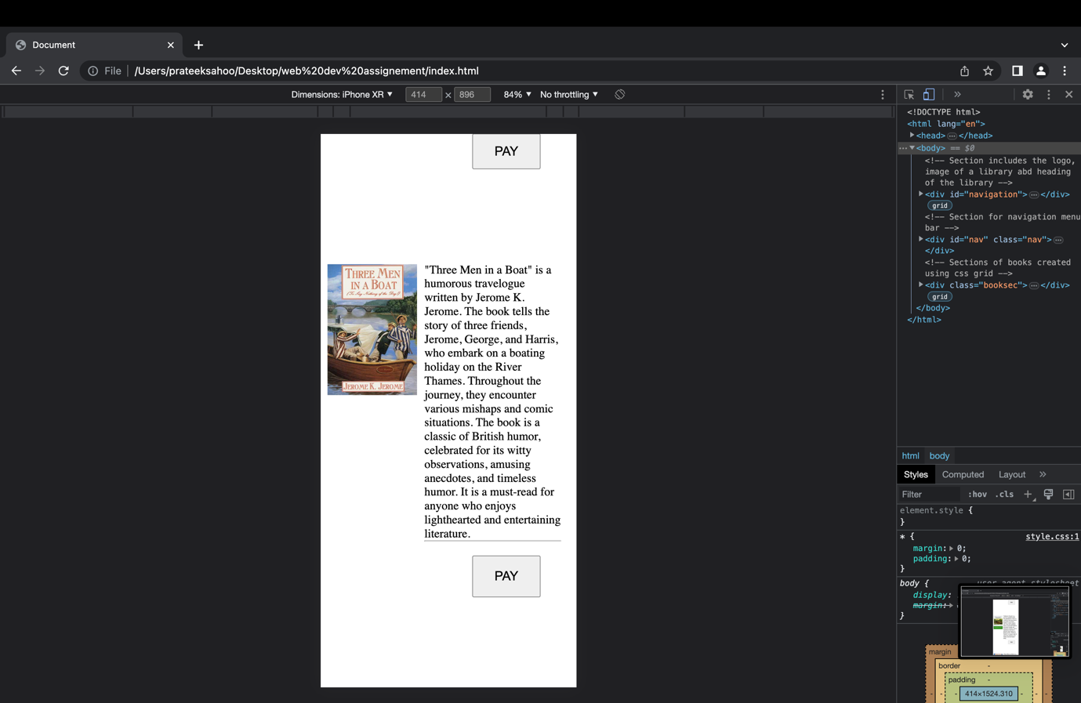

Menu bar after clicking the hamburger:

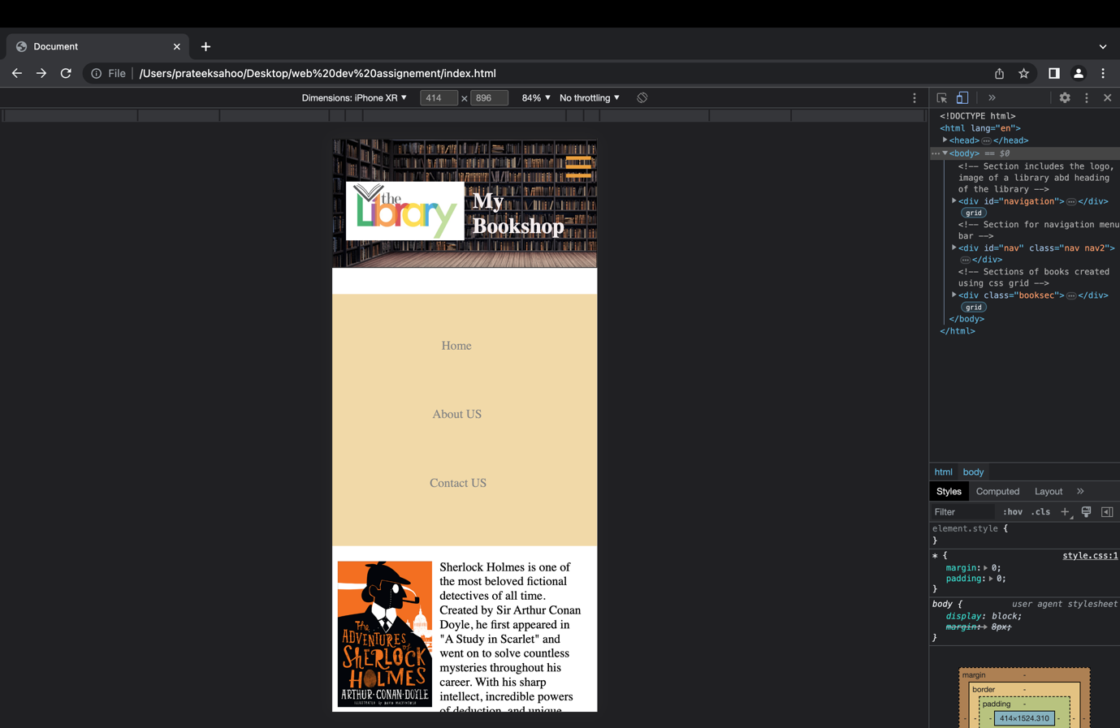

Smartphone view: Pay page (iPhone XR)

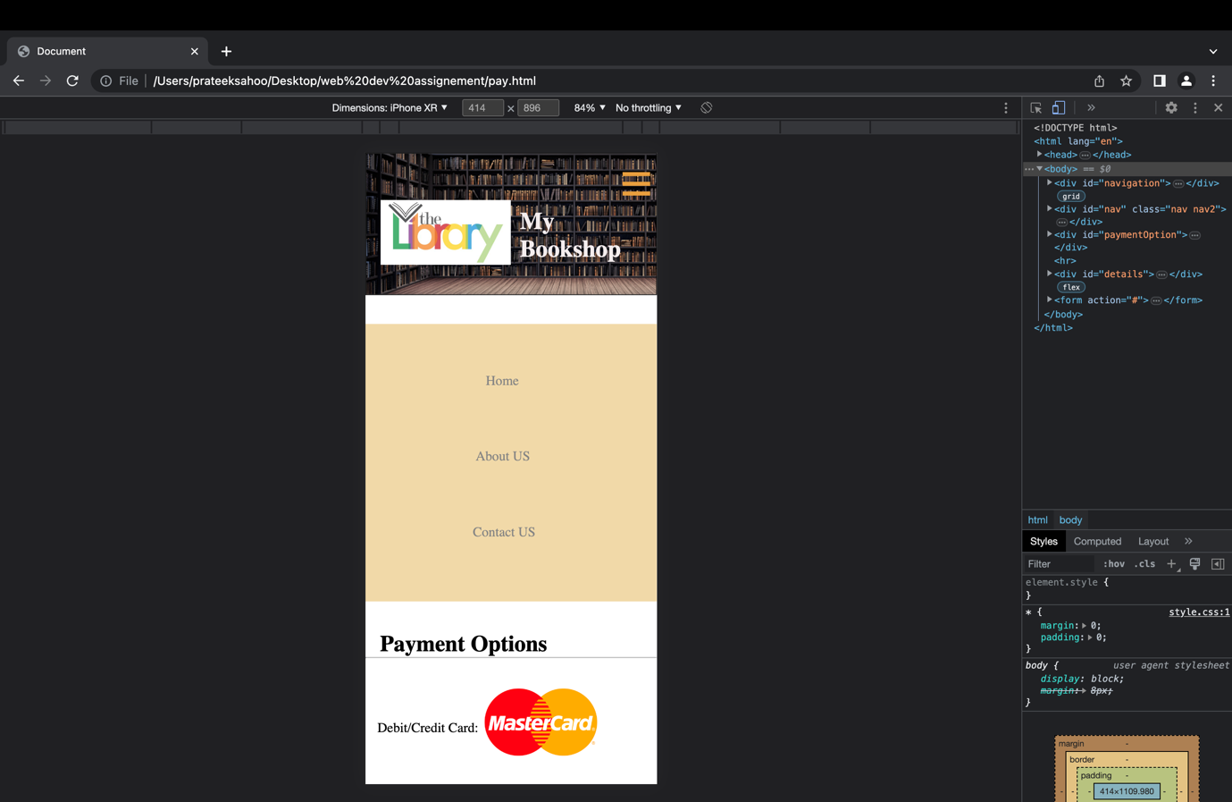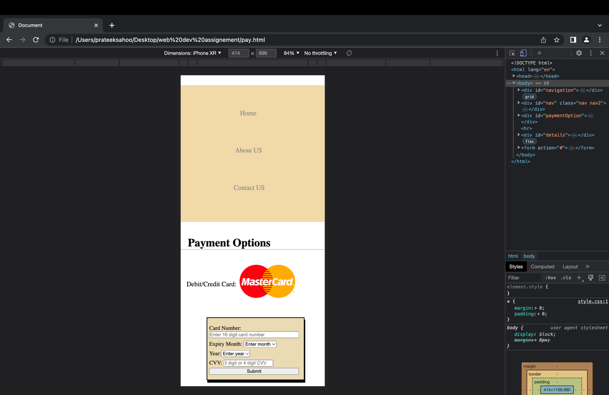

Smartphone view: Success Page (iPhone XR)

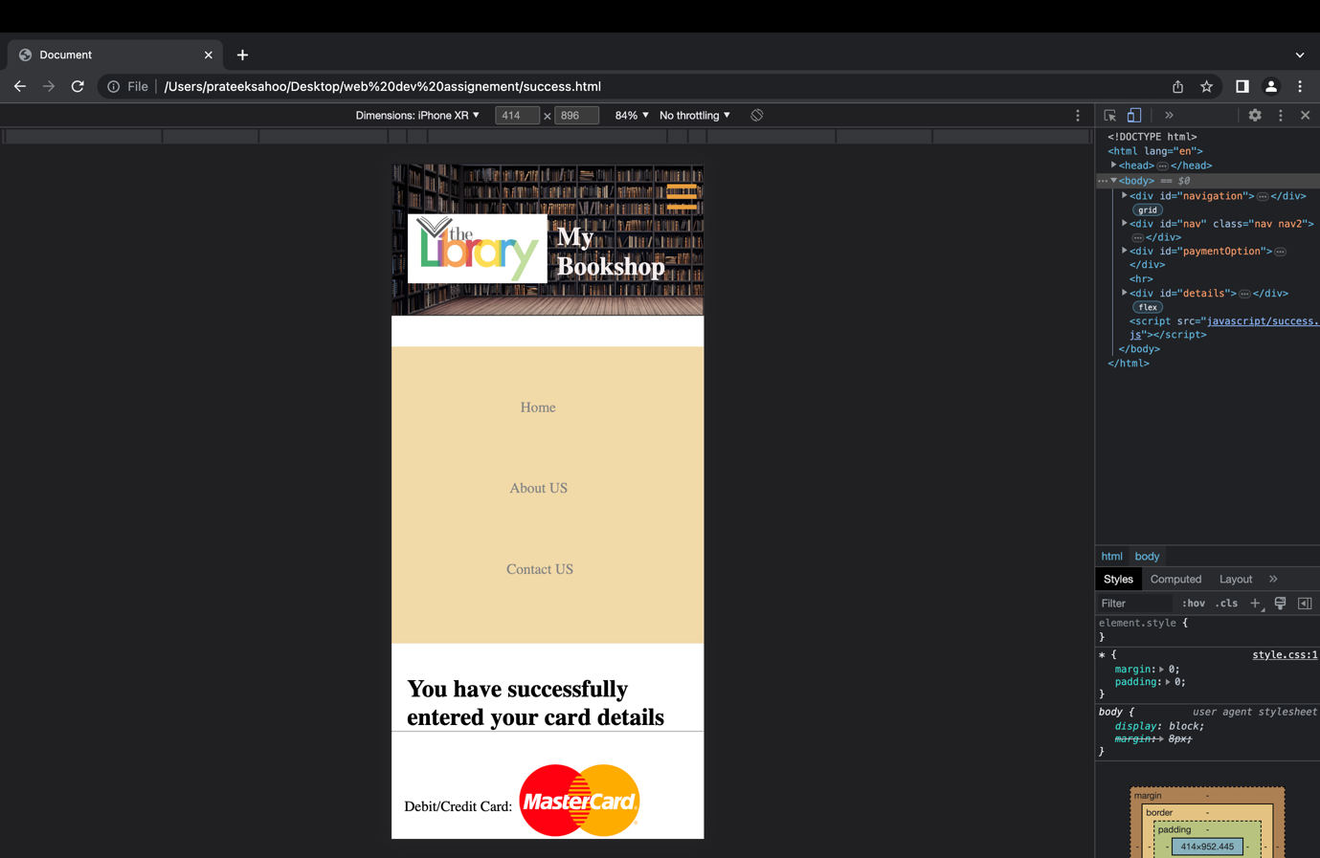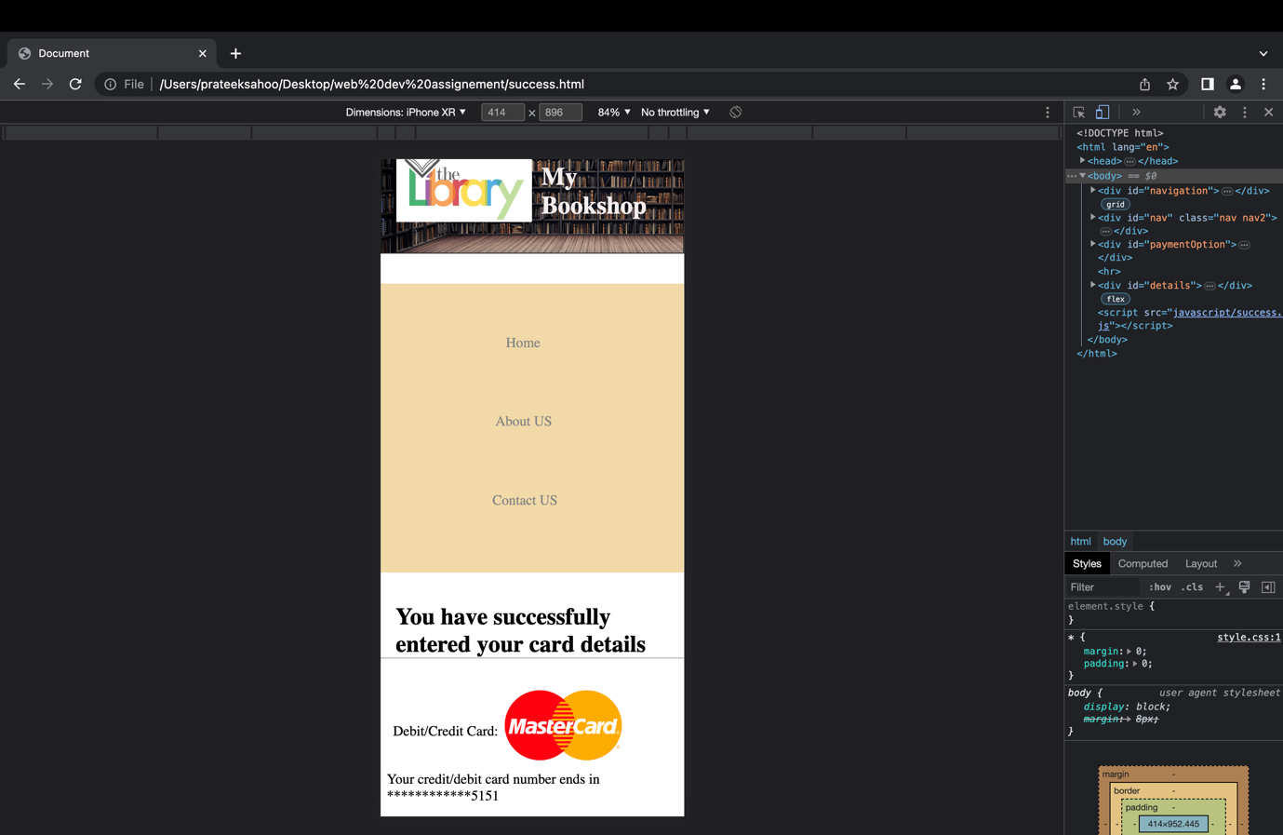

Section-C: RESTful

Screenshot raw JSON data:

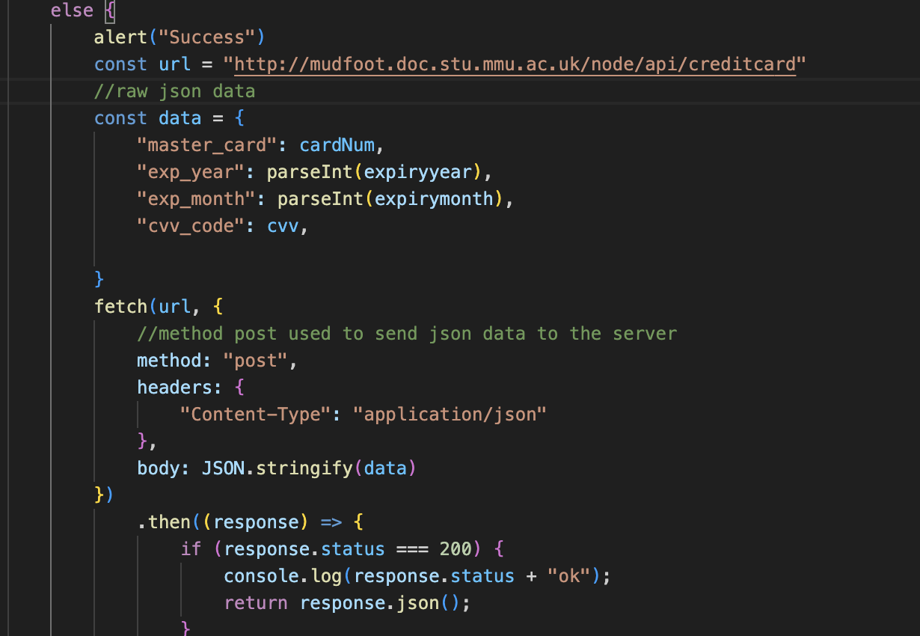

Validation code:

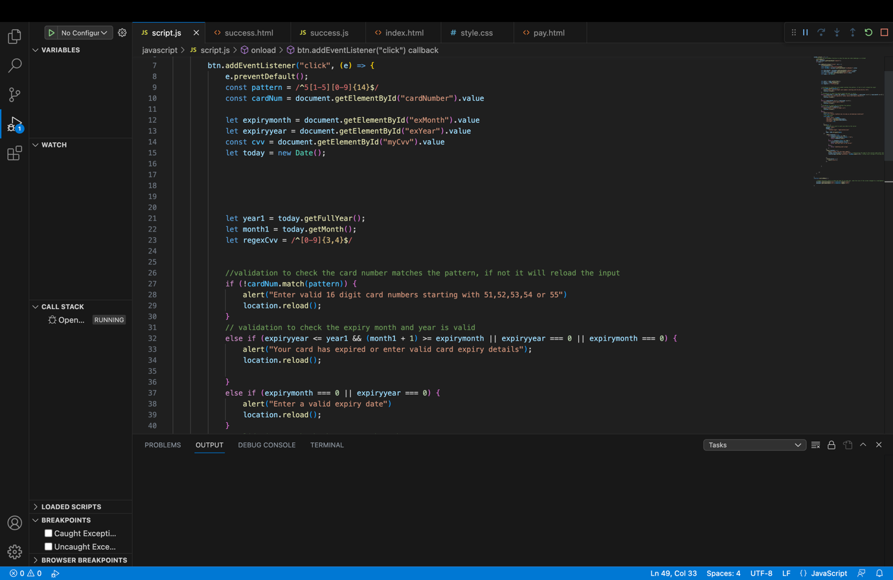

Validation in pay page showing alert box when sending wrong card details:

* When wrong card number entered, or the input left empty:

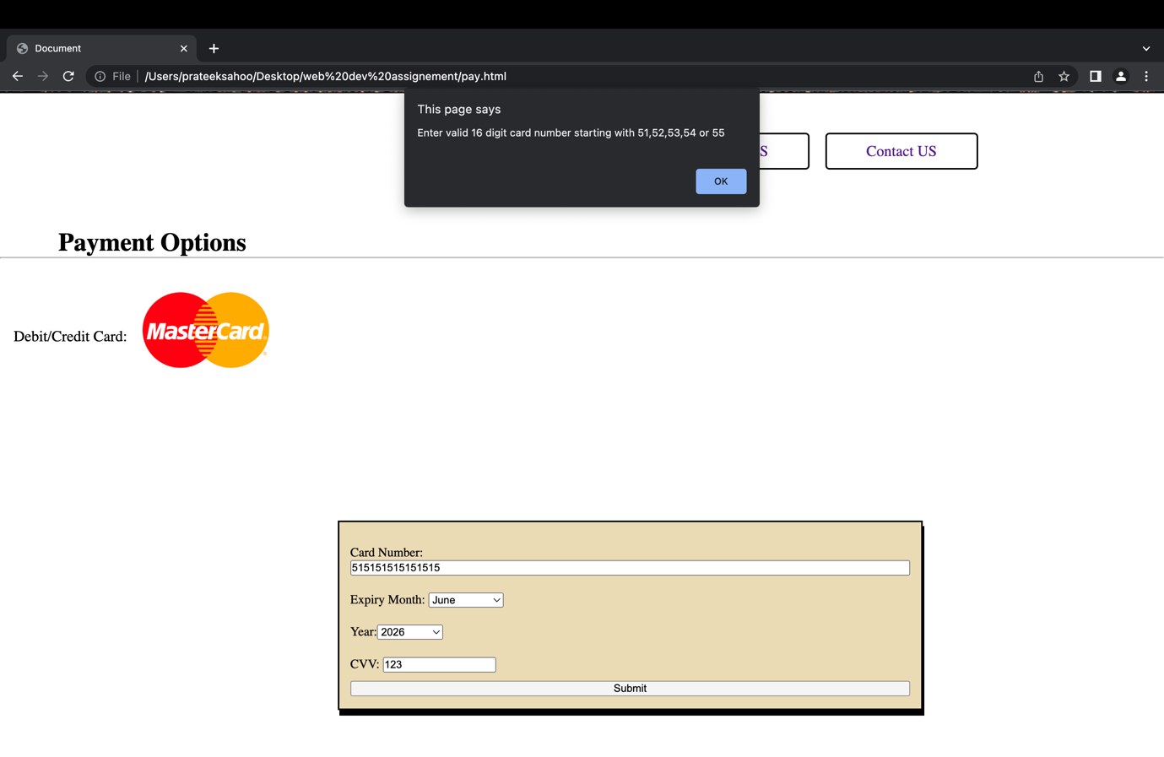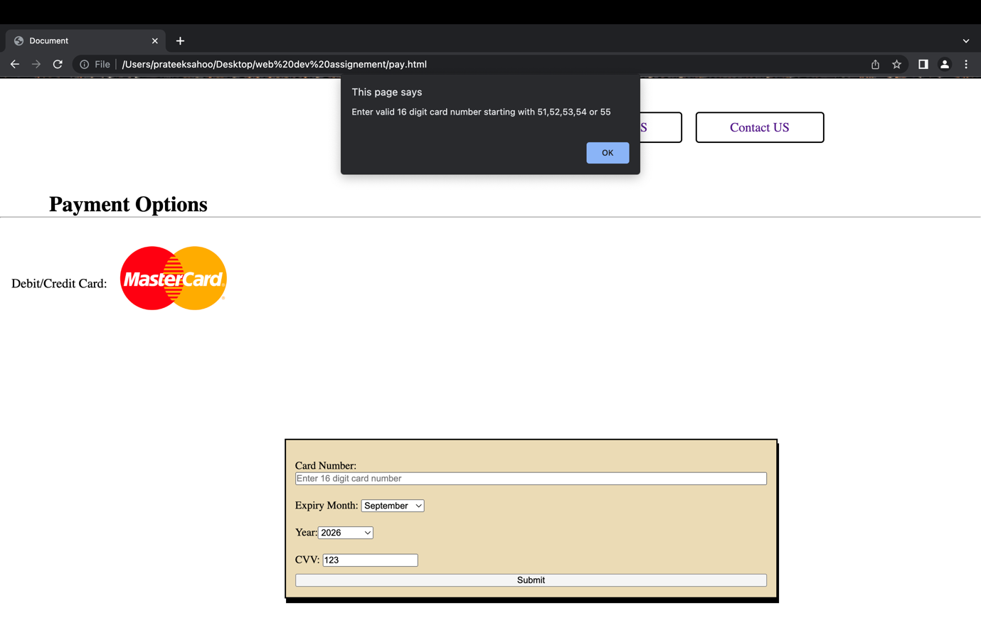

* When wrong expiry month and year entered or left empty or unchanged:

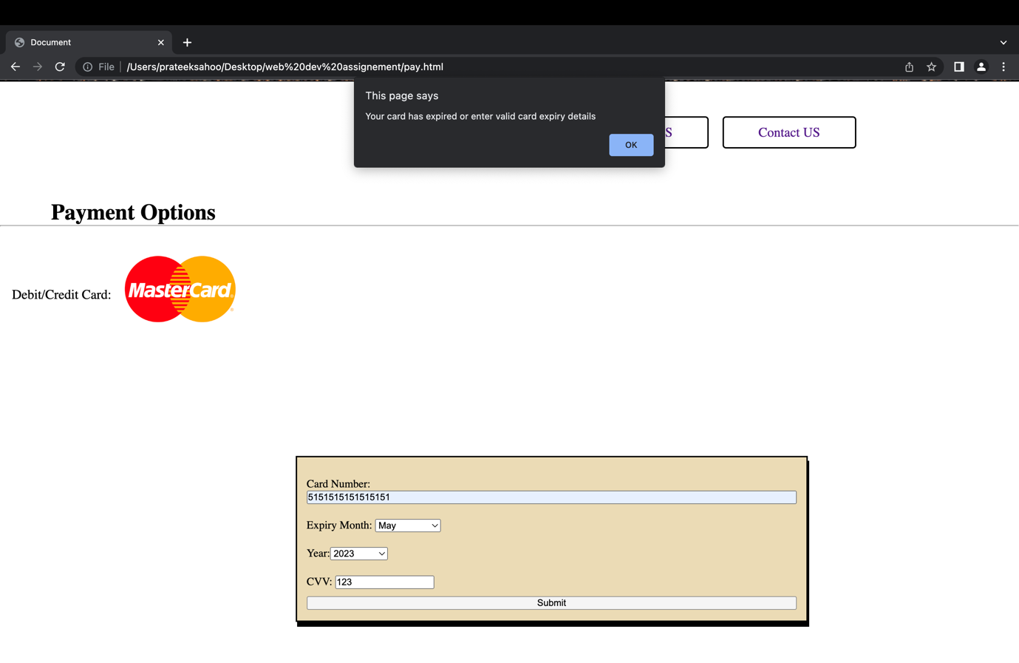

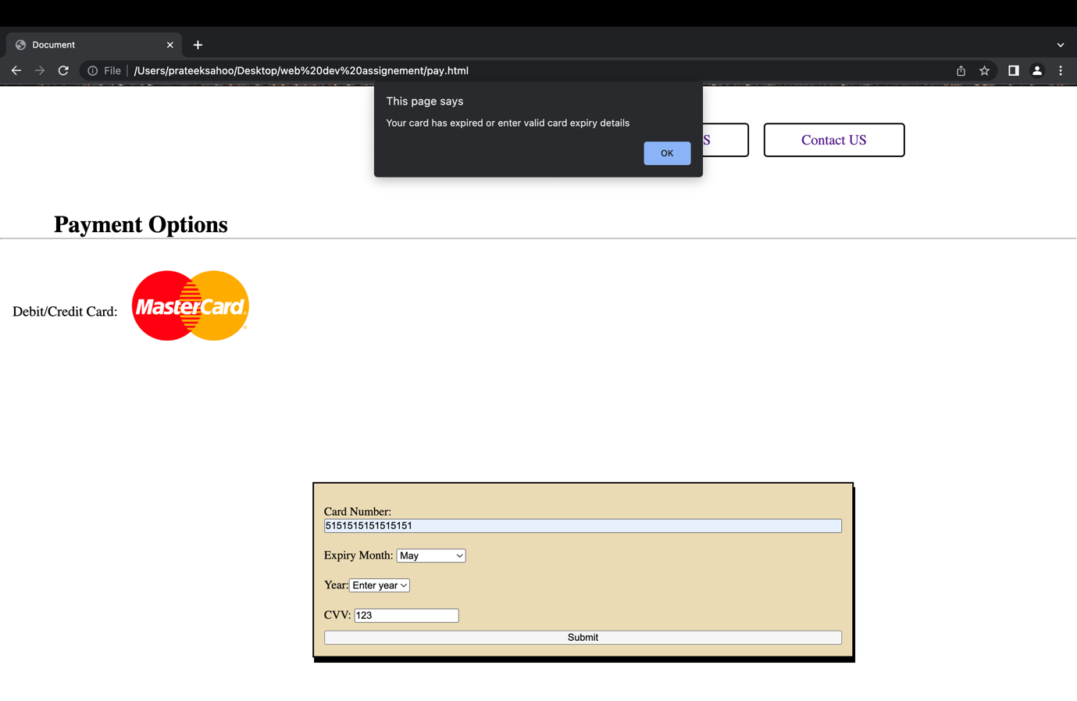

* Wrong CVV input entered or left empty:

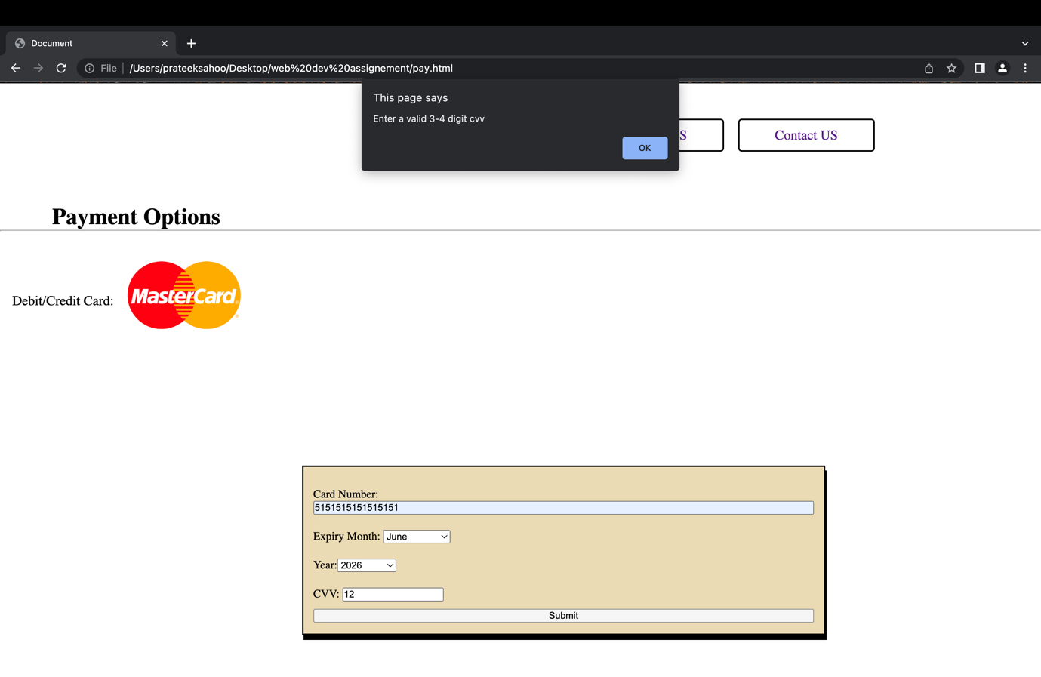

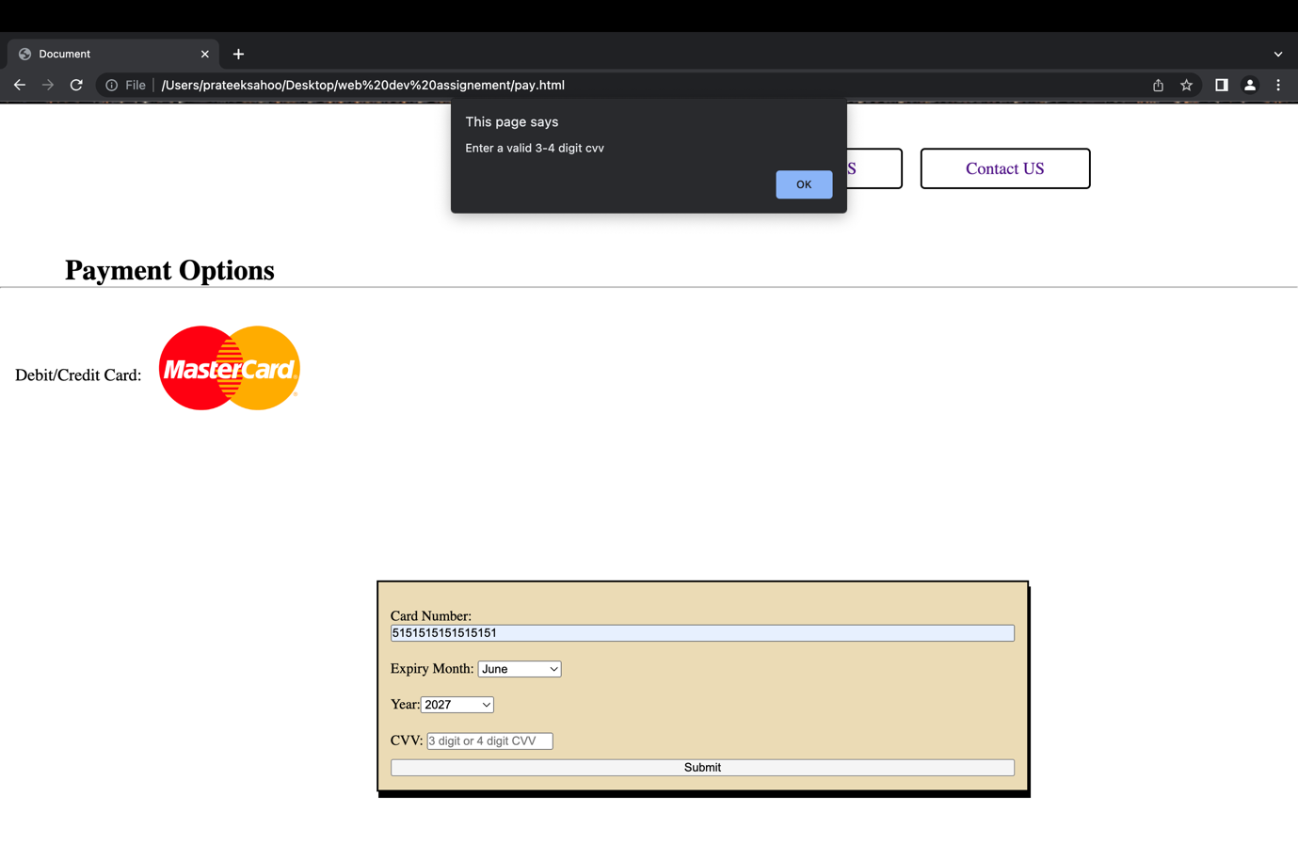

Screenshot of success: Status 200

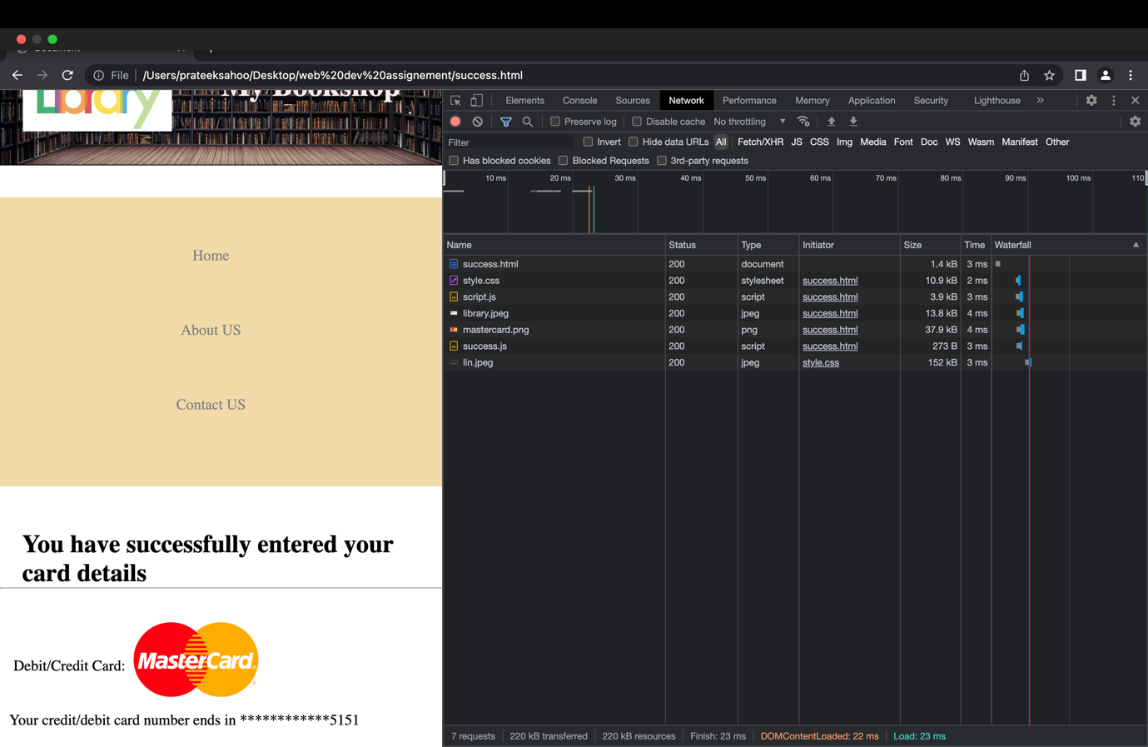

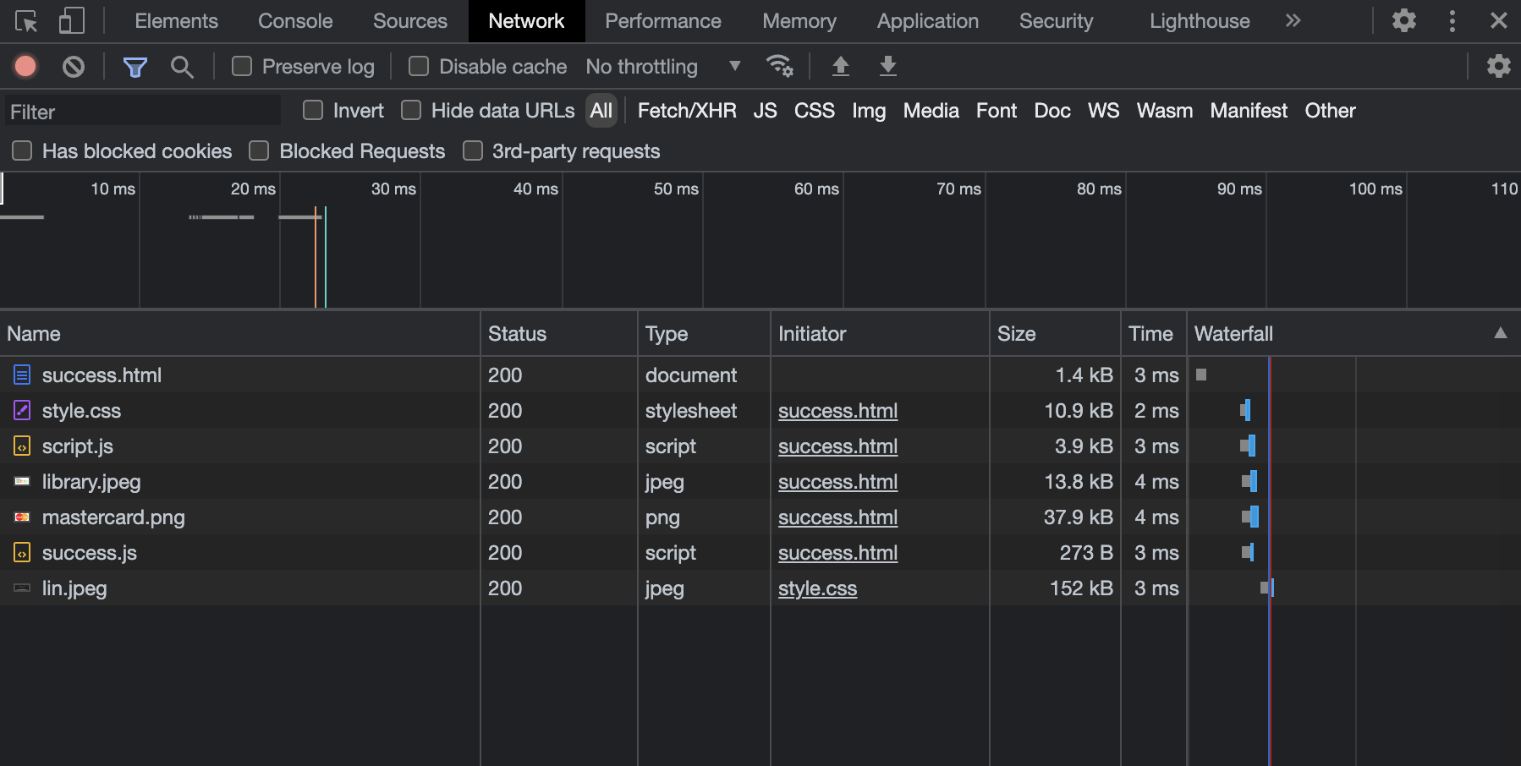

Section-D: Usability and accessibility:

1. Clarity: I made sure my website is very easy and efficient for the users. I kept the website’s goal clear for example if a user visits my website, he/she will be clear about the actual purpose of the website.
2. Consistency: I made sure the design of all my web pages looks the same. I don’t want to create any confusion in the user’s mind about my website. I kept the layout the same as well my navigation menu bar. The Nav menu bar is consistent throughout.
3. Simplicity: Made my website easy to use and efficient so that users can easily interact with it. My website is so simple that it can be easily used by old people, adults, and children as well.
4. Responsive: My website works properly for all smartphone screen sizes. Used media query to achieve that.
5. Used “alt” keyword as an alternative name for my images and “src” for linking the image.
6. Used “href” keyword to link my pages and CSS stylesheet.
7. Language set English using html lang=”en”.
8. Used meaningful page title using <title>.